

**APNA CINEMA**

**(E-Ticket Booking Website)**

**PROJECT REPORT**

**Bachelor In Technology**

**in**

**Computer Science and Engineering**

By

**ARYAN JAISWAL (20217)**

Supervisor

**Prof. ANIRUDDH KUMAR**

**COMPUTER SCIENCE AND ENGINEERING DEPARTMENT**

**KAMLA NEHRU INSTITUTE OF TECHNOLOGY, SULTANPUR, INDIA**

**INDEX**

|  |  |  |
| --- | --- | --- |
| **Sr.no** | **Title** | **Page No** |
| **1.** | **ACKNOWLEDGEMENT** | **1** |
| **2.** | **CERTIFICATE** | **2** |
| **3.** | **INTRODUCTION** | **3** |
| **4.** | **FEATURES** | **4** |
| **5.** | **SOFTWARE REQUIREMENTS** | **8** |
| **6.** | **PROJECT DISCRIPTION** | **10** |
| **7.** | **REFERENCE** | **11** |

**ACKNOWLEDGEMENT**

This is to acknowledge all those without whom this

Project would not have been a reality. Firstly, We would like to thank the **Prof. Aniruddh Kumar** who gave their immense support and made us understand how to make this project. Without their guidance, the project would

not have been complete. We are glad that we were able

to complete this project and understand many things.The preparation of this project was an immense learning experience and we inculcated many personal qualities during this process like responsibility, punctuality, confidence and others.

**CERTIFICATE**

This is to certify that **APNA CINEMA** is bonafide work of

**ARYAN JAISWAL (20217)** during this project submission

as partial fulfillment of the requirement.

For the **MINI PROJECT** of Bachelor in Technology III Semester of Kamla Nehru Institute of Technology, Sultanpur in session2021-22. It has been found to be satisfactory and hereby approved for submission .

**(HOD CSE Department) (Project Guide)**

**INTRODUCTION**

* **Overview:**

Comfort is a feeling which every human want in their life. They try to entertain themselves by watching movies ,shows etc. But what

happen if they have to wait in long queue, it can spoil their enjoyment.

So to deal with, I build APNA CINEMA , a E-Ticket Booking Website.

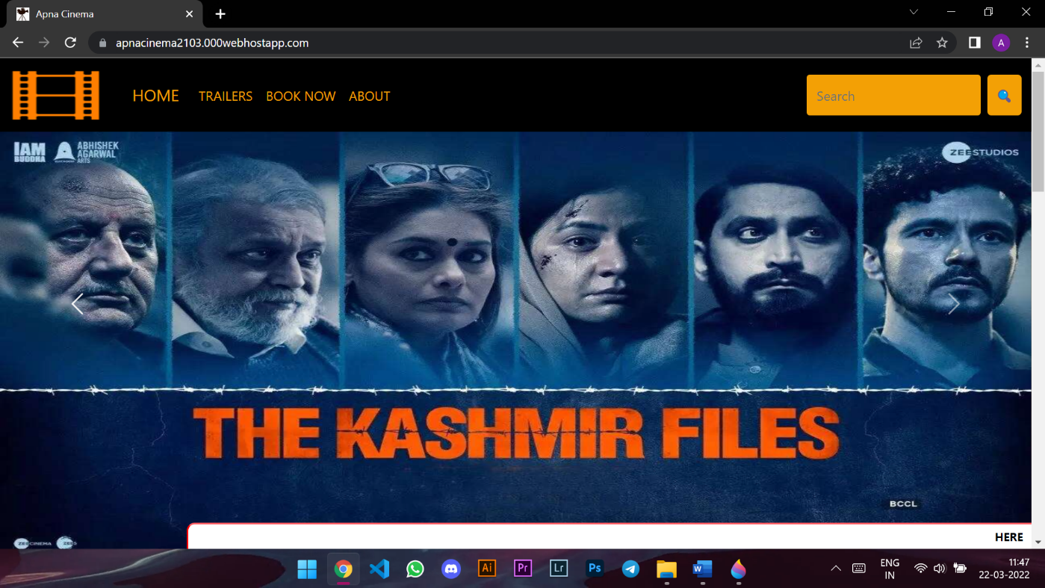

APNA CINEMA lets you to know which movies are currently showing

or are upcoming in the theatre either they are Bollywood or

Hollywood.

**FEATURES**

**1.Main Page:**

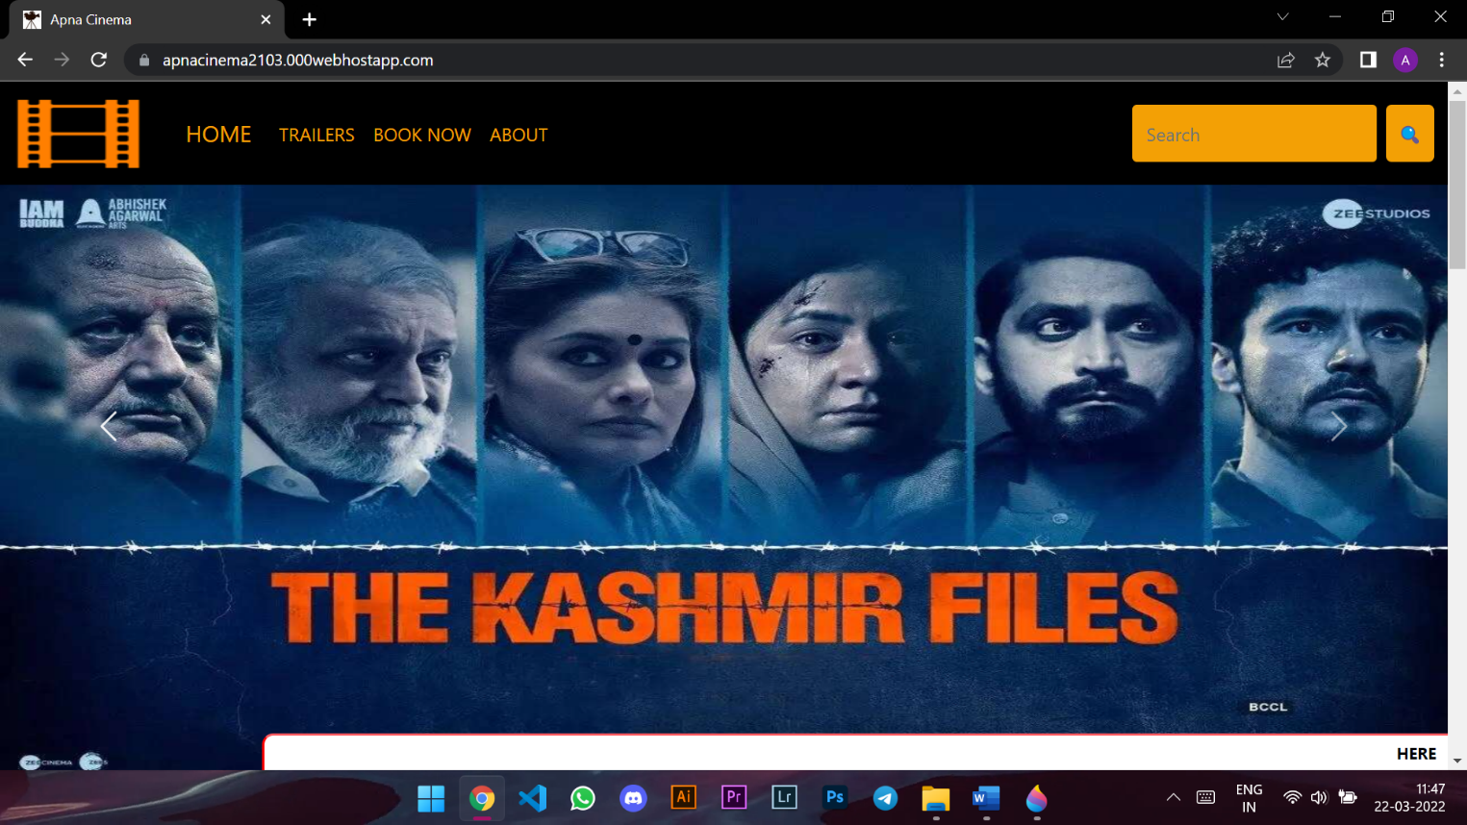

When you open website, there is navigation bar consist of logo and buttons which lets you to navigate throughout the website .Next you see a carousel

which consist of movies poster which gets changed after a particular interval.

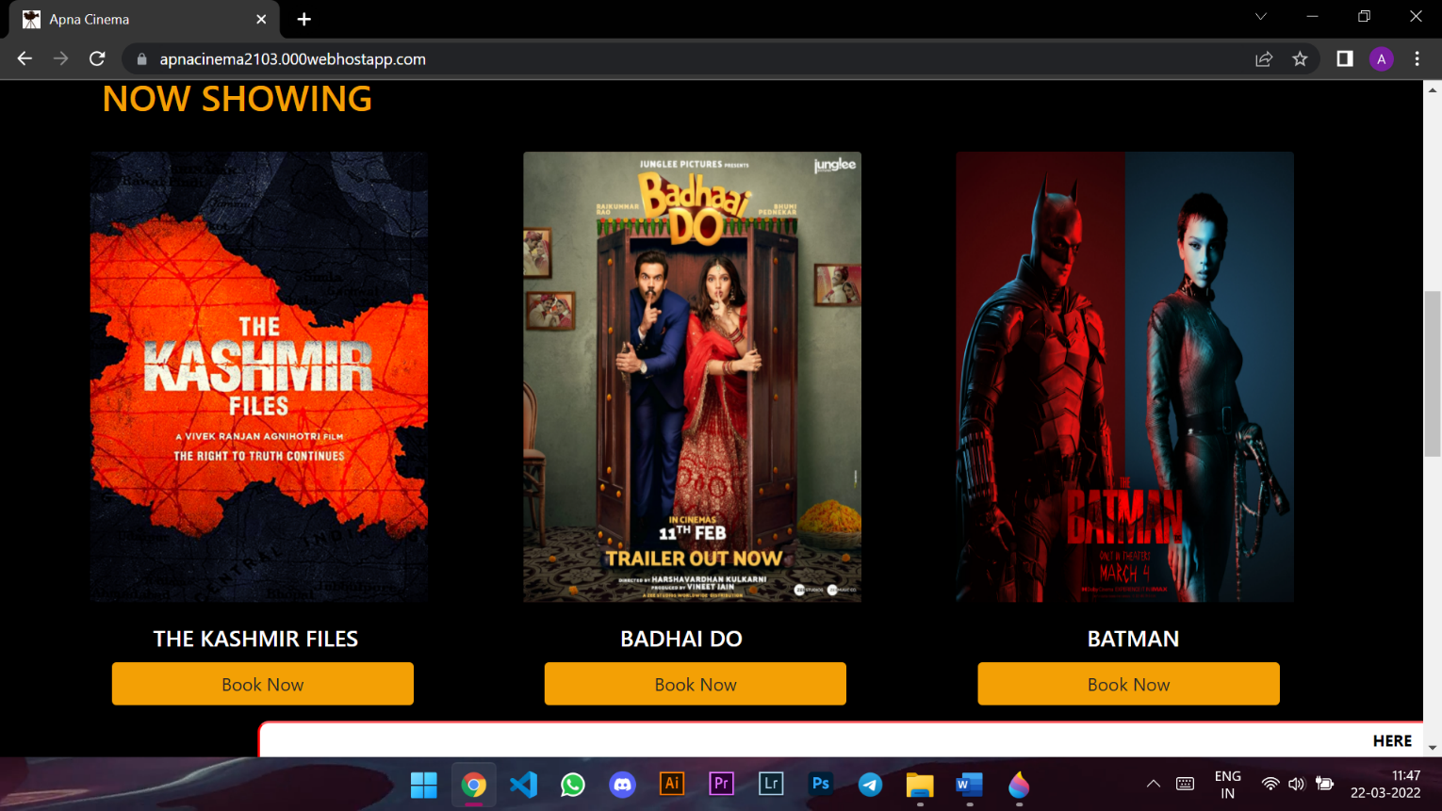

Next you see lists of movies in two section now showing and upcoming

which consist of poster and title of the movie . You can click on book now to

watch the trailer and book tickets.

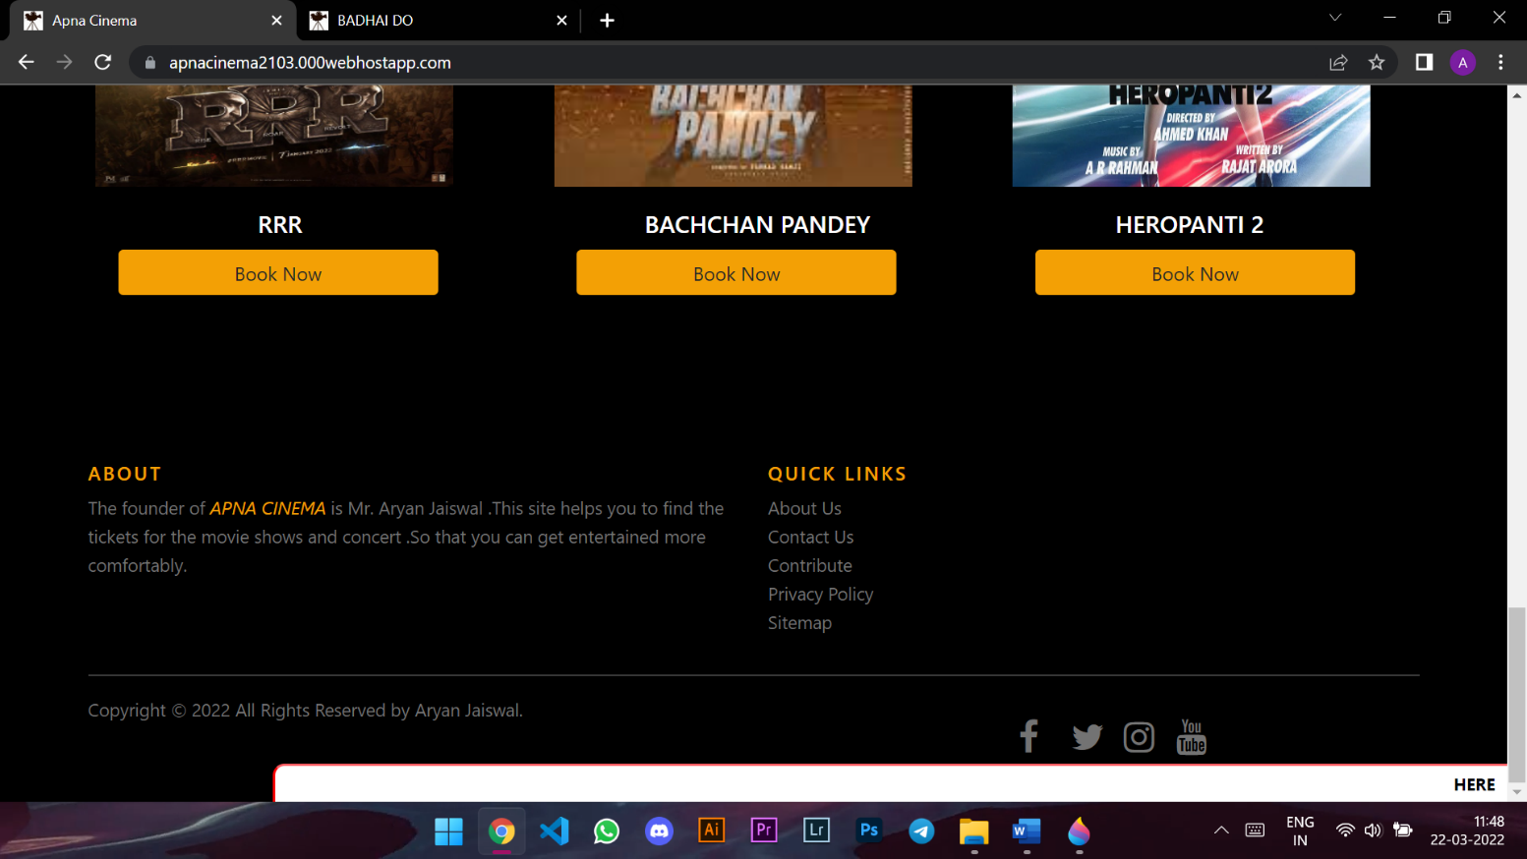

At the end ,a section contain about the website, quick links, copyrights

and all social media logo hyperlinks which can help you to contact with

us.

**2.Booking page:**

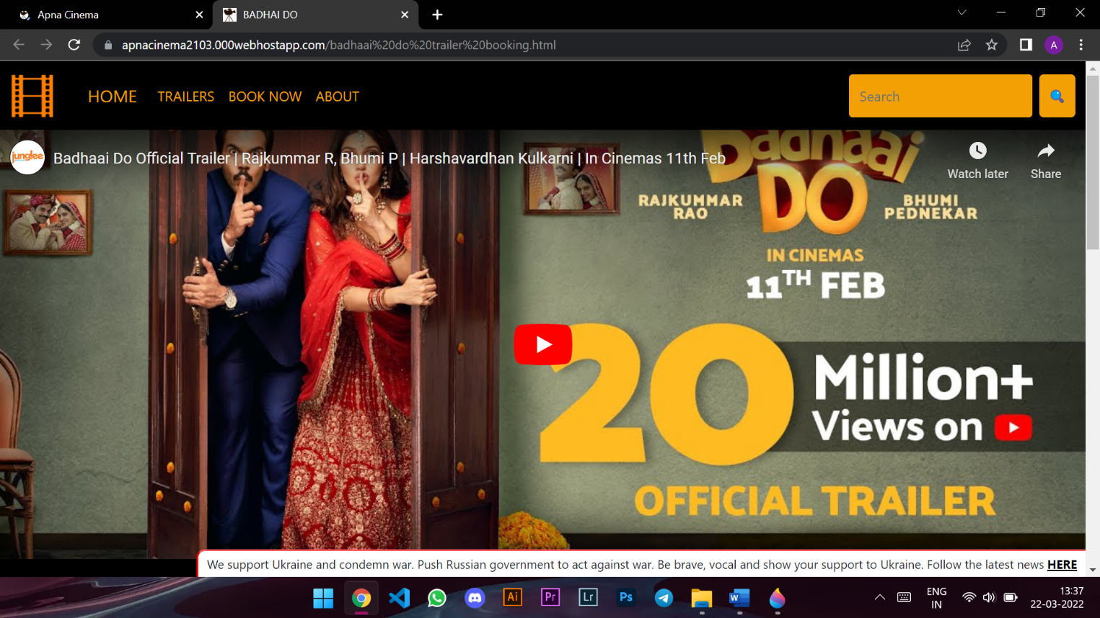

This page contain all the booking procedure .Firstly you see the

trailer of the movie which helps you to get an overview about the movie.

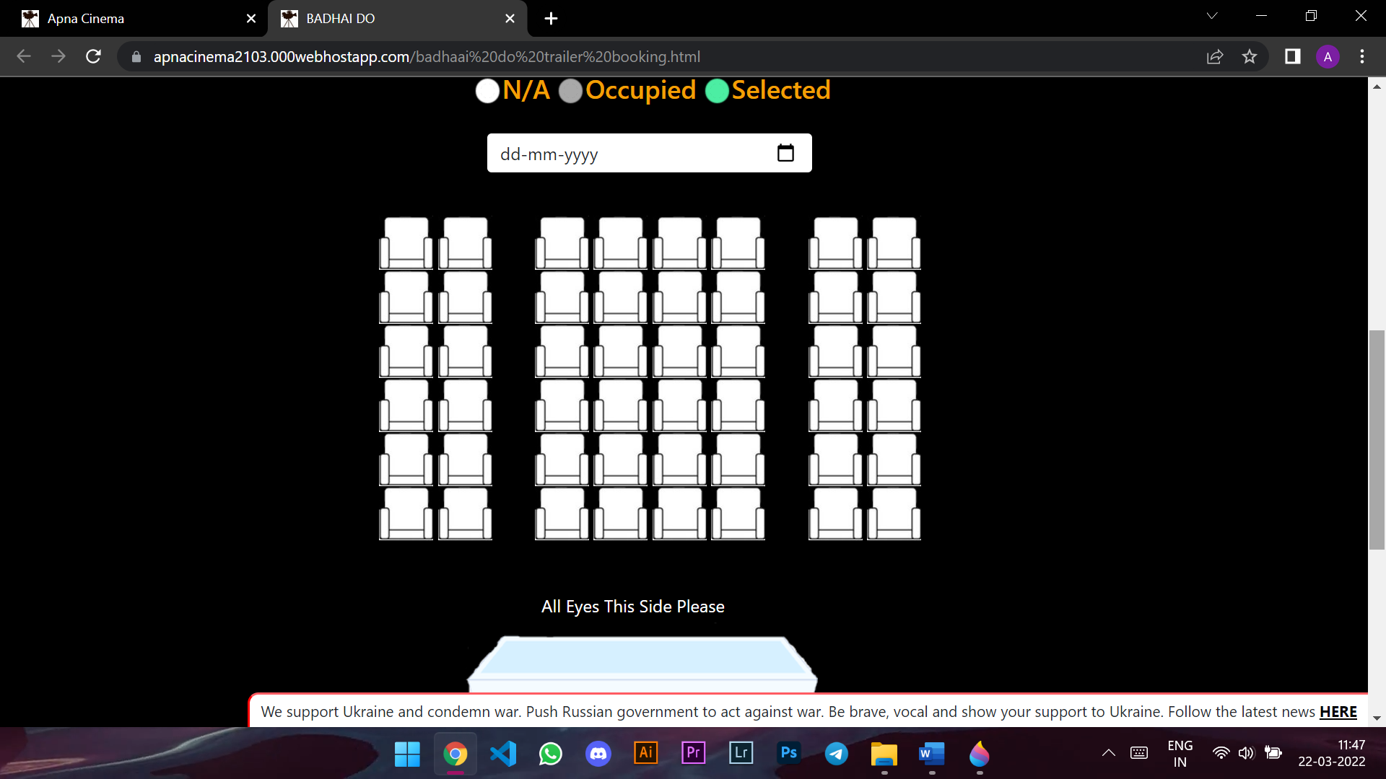

After which you select the date on which you want to movie and the seats you want to book.

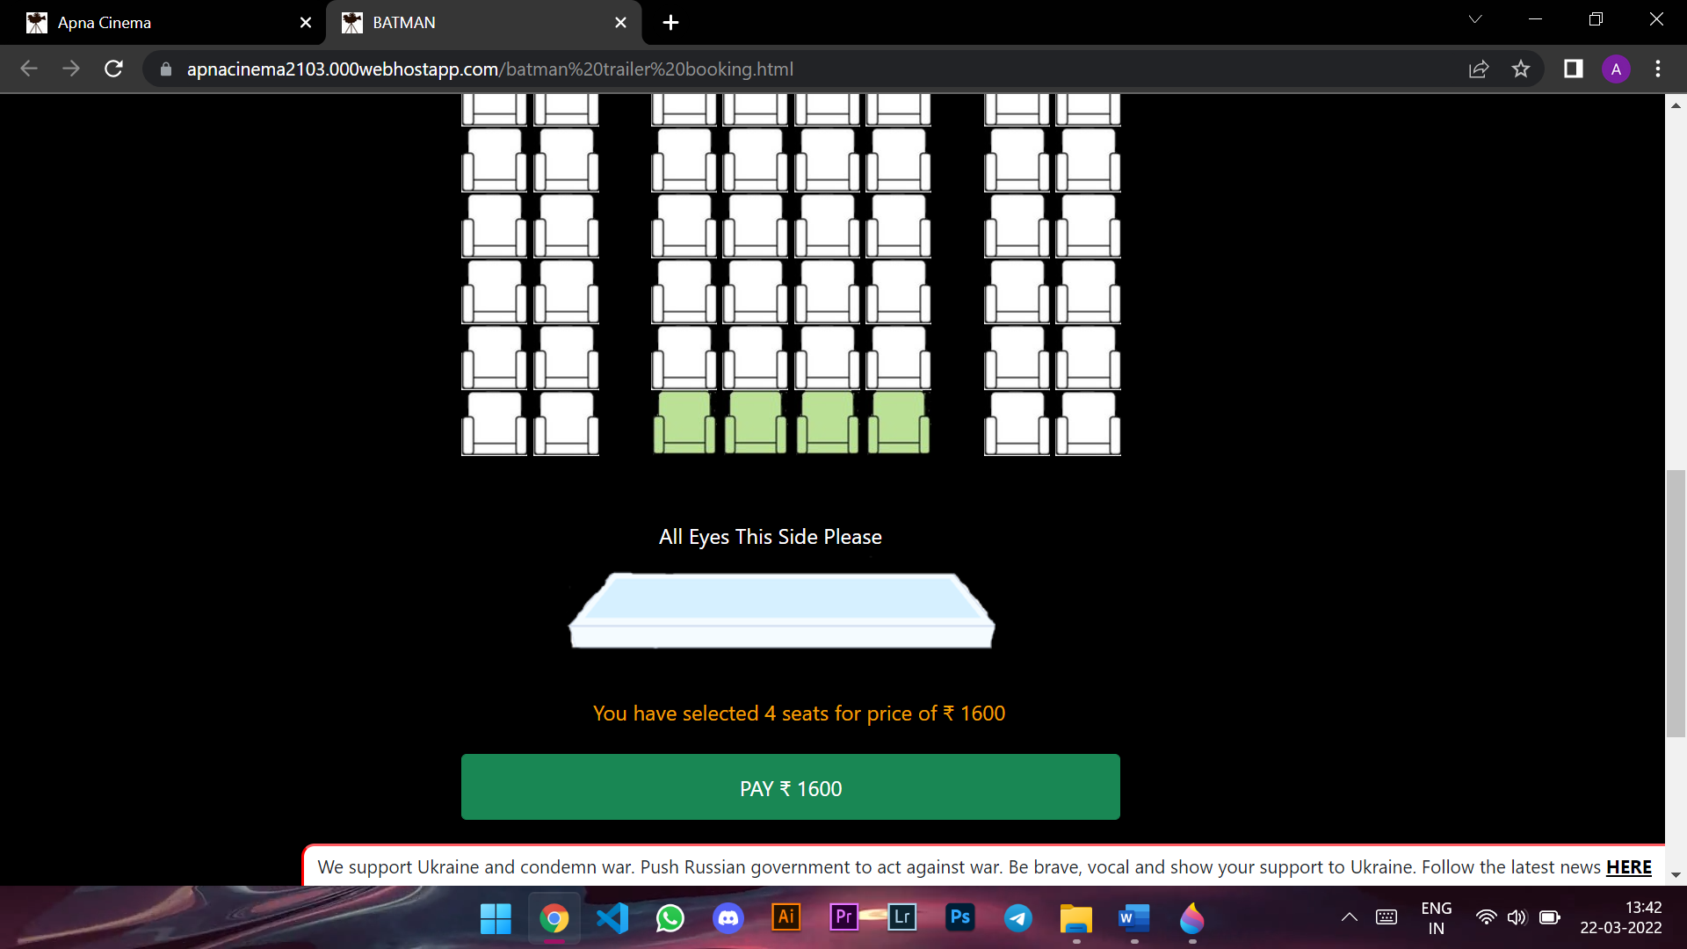

You will be shown the amount and no of seats and a pay button consisting your amount.

**3.Payment Page:**

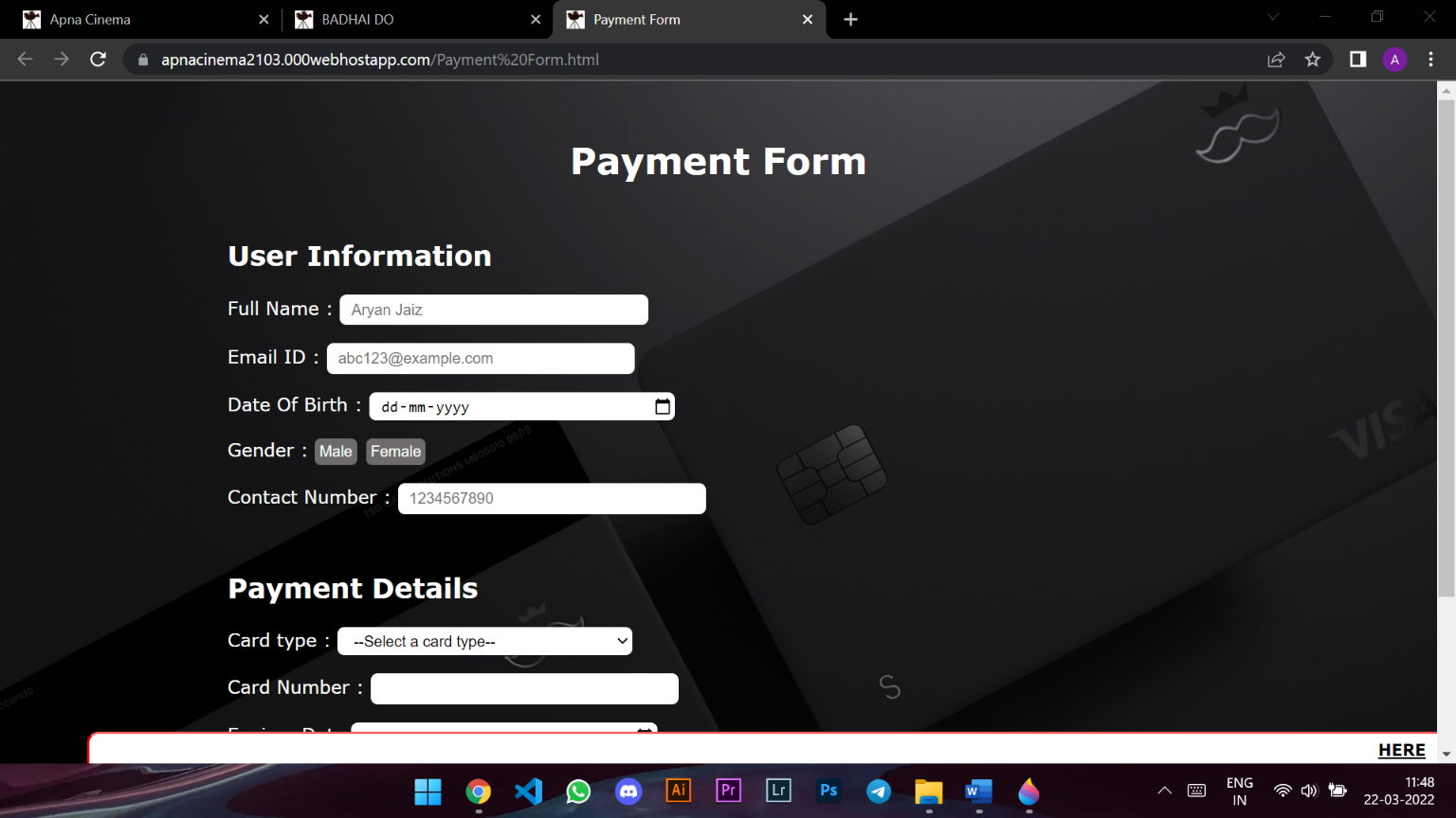

This page consist of all the payment related credential. It will take

your personal information and card details and you have agree on

our terms and condition for further transaction and booking of your tickets.

**Software requirements**

**1.HTML :**

The **Hyper Text Markup Language** or **HTML** is the standard [markup language](https://en.wikipedia.org/wiki/Markup_language) for documents designed to be displayed in a [web browser](https://en.wikipedia.org/wiki/Web_browser). It

can be assisted by technologies such as [Cascading Style Sheets](https://en.wikipedia.org/wiki/Cascading_Style_Sheets) (CSS) and [scripting languages](https://en.wikipedia.org/wiki/Scripting_language) such as [JavaScript](https://en.wikipedia.org/wiki/JavaScript).

[Web browsers](https://en.wikipedia.org/wiki/Web_browser) receive HTML documents from a [web server](https://en.wikipedia.org/wiki/Web_server) or from local storage and [render](https://en.wikipedia.org/wiki/Browser_engine) the documents into multimedia web pages. HTML describes the structure of a [web page](https://en.wikipedia.org/wiki/Web_page) [semantically](https://en.wikipedia.org/wiki/Semantic_Web) and originally

included cues for the appearance of the document.

**2.CSS :**

**Cascading Style Sheets** (**CSS**) is a [style sheet language](https://en.wikipedia.org/wiki/Style_sheet_language) used for describing the [presentation](https://en.wikipedia.org/wiki/Presentation_semantics) of a document written in a [markup language](https://en.wikipedia.org/wiki/Markup_language) such as [HTML](https://en.wikipedia.org/wiki/HTML). CSS is a cornerstone technology of the

[World Wide Web](https://en.wikipedia.org/wiki/World_Wide_Web), alongside HTML and [JavaScript](https://en.wikipedia.org/wiki/JavaScript).

CSS is designed to enable the separation of presentation and content, including [layout](https://en.wikipedia.org/wiki/Page_layout), color, and [fonts](https://en.wikipedia.org/wiki/Typeface). This separation can improve content [accessibility](https://en.wikipedia.org/wiki/Accessibility); provide more flexibility and control in the

specification of presentation characteristics; enable multiple [web pages](https://en.wikipedia.org/wiki/Web_page)

to share formatting by specifying the relevant CSS in a separate .CSS

file, which reduces complexity and repetition in the structural content and enable the .CSS file to be [cached](https://en.wikipedia.org/wiki/Cache_(computing)) to improve the page load speed

between the pages that share the file and its formatting.

**3.JAVASCRIPT:**

**JavaScript** often abbreviated **JS**, is a [programming language](https://en.wikipedia.org/wiki/Programming_language) that is one

of the core technologies of the [World Wide Web](https://en.wikipedia.org/wiki/World_Wide_Web) alongside [HTML](https://en.wikipedia.org/wiki/HTML) and [CSS](https://en.wikipedia.org/wiki/CSS). Over 97% of [websites](https://en.wikipedia.org/wiki/Website) use JavaScript on the [client](https://en.wikipedia.org/wiki/Client_(computing)) side for [web page](https://en.wikipedia.org/wiki/Web_page) behaviour.

All major [web browsers](https://en.wikipedia.org/wiki/Web_browser) have a dedicated [JavaScript engine](https://en.wikipedia.org/wiki/JavaScript_engine) to execute the [code](https://en.wikipedia.org/wiki/Source_code) on [users](https://en.wikipedia.org/wiki/User_(computing))' devices.

JavaScript is a [high-level](https://en.wikipedia.org/wiki/High-level_programming_language), often [just-in-time compiled](https://en.wikipedia.org/wiki/Just-in-time_compilation) language that conforms to the [ECMAScript](https://en.wikipedia.org/wiki/ECMAScript) standard. It has [dynamic typing](https://en.wikipedia.org/wiki/Dynamic_typing), [prototype-based](https://en.wikipedia.org/wiki/Prototype-based_programming) [object-orientation](https://en.wikipedia.org/wiki/Object-oriented_programming), and [first-class functions](https://en.wikipedia.org/wiki/First-class_function). It is [multi-paradigm](https://en.wikipedia.org/wiki/Programming_paradigm), supporting [event-driven](https://en.wikipedia.org/wiki/Event-driven_programming), [functional](https://en.wikipedia.org/wiki/Functional_programming), and [imperative](https://en.wikipedia.org/wiki/Imperative_programming) [programming styles](https://en.wikipedia.org/wiki/Programming_paradigm).

It has [application programming interfaces](https://en.wikipedia.org/wiki/Application_programming_interface) (APIs) for working with text, dates, [regular expressions](https://en.wikipedia.org/wiki/Regular_expression), standard [data structures](https://en.wikipedia.org/wiki/Data_structure), and the [Document Object Model](https://en.wikipedia.org/wiki/Document_Object_Model) (DOM).

**4.VISUAL CODE EDITOR:**

**Visual Studio Code** is a [source-code editor](https://en.wikipedia.org/wiki/Source-code_editor) made by [Microsoft](https://en.wikipedia.org/wiki/Microsoft) for [Windows](https://en.wikipedia.org/wiki/Windows), [Linux](https://en.wikipedia.org/wiki/Linux) and [macOS](https://en.wikipedia.org/wiki/MacOS). Features include support for [debugging](https://en.wikipedia.org/wiki/Debugging), [syntax highlighting](https://en.wikipedia.org/wiki/Syntax_highlighting), [intelligent code completion](https://en.wikipedia.org/wiki/Intelligent_code_completion), [snippets](https://en.wikipedia.org/wiki/Snippet_(programming)), [code refactoring](https://en.wikipedia.org/wiki/Code_refactoring), and embedded [Git](https://en.wikipedia.org/wiki/Git). Users can change the [theme](https://en.wikipedia.org/wiki/Theme_(computing)), [keyboard shortcuts](https://en.wikipedia.org/wiki/Keyboard_shortcut), preferences, and install [extensions](https://en.wikipedia.org/wiki/Plug-in_(computing)) that add additional functionality.

In the [Stack Overflow](https://en.wikipedia.org/wiki/Stack_Overflow) 2021 Developer Survey, Visual Studio Code was ranked the most popular developer environment tool, with 70% of 82,000 respondents reporting that they use it.

**PROJECT DISCRIPTION**

● Create the basic structure of the webpage using basic Html and CSS.

● With the help of CSS we created navigation bar and the cards on

which movie poster and book now button is present.

●At the end of every page with the help of css and hover property we created an about section and contact us on social media section.

● Logic behind making a carousel which gets change after an interval selection of seats and showing the amount and

selected number of seats and pay button. This part is achieved by

using JavaScript.

●By building this project we have clear understanding of HTML ,CSS

And Javascript.

●With help of this project we get various methods for implementation

of javascript.

●We get know about how the website work and how we host them.

We can have the practical knowledge of developing a website.

**Reference**

* [www.google.com(google)](http://www.google.com(google))
* https://code.visualstudio.com/ (code editor)
* <https://en.wikipedia.org/wiki/Main_Page> (WIKIPEDIA)
* https://www.w3schools.com/js/default.asp (javascript)
* https://www.w3schools.com/html/default.asp (html)
* https://www.w3schools.com/css/default.asp (css)
* <https://getbootstrap.com(bootstrap)>
* <https://in.000webhost.com/free-website-sign-up> (hosting)
* <https://www.geeksforgeeks.org> (geeks for geeks)